|  |  |  |  |  |  |
| --- | --- | --- | --- | --- | --- |
| Date | 27-Sep-22 | | | Tester Name | Shahabuddin Syed |
| Environment | Penfax - Test | | | Login used |  |
| Operating System | Select OS | Version: | Update: | | |
| Software Used | Select Software | Version: | Update: | | |
| Select Software | Version: | Update: | | |
| Release version | 22.3.0 | | | | |
| Title | E21.12 | | | | |
| Test Type | Regression | | | | |
| Test Scenario | Lock Penfax Account & Confirm Validation when processing payments (Penfax and PENWEB) | | | | |
|  |  | | | | |
| Expected Results |  | | | | |
| Pass/Fail | Pass | | | JIRA# | N/A |

Describe your steps with screenshots:

Search for any Employer in the PEPP Plan

SID- 311514

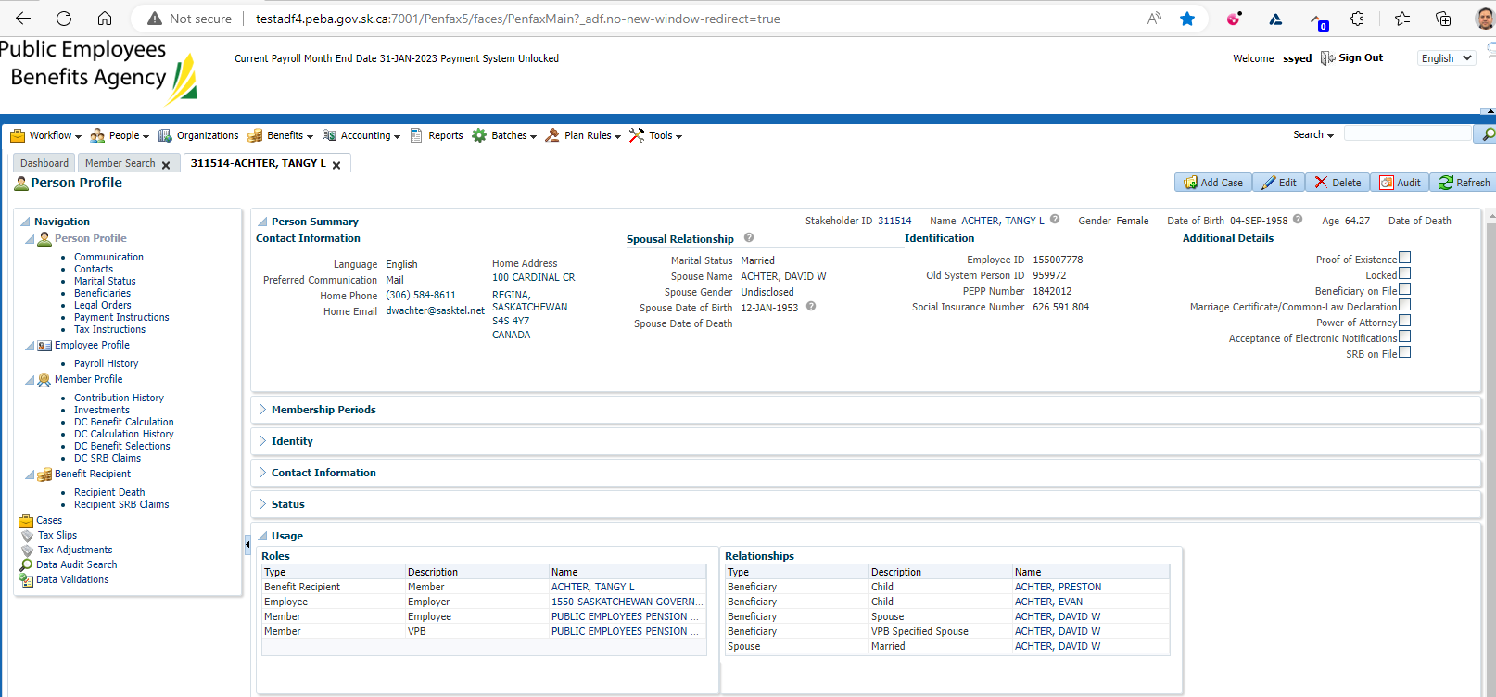

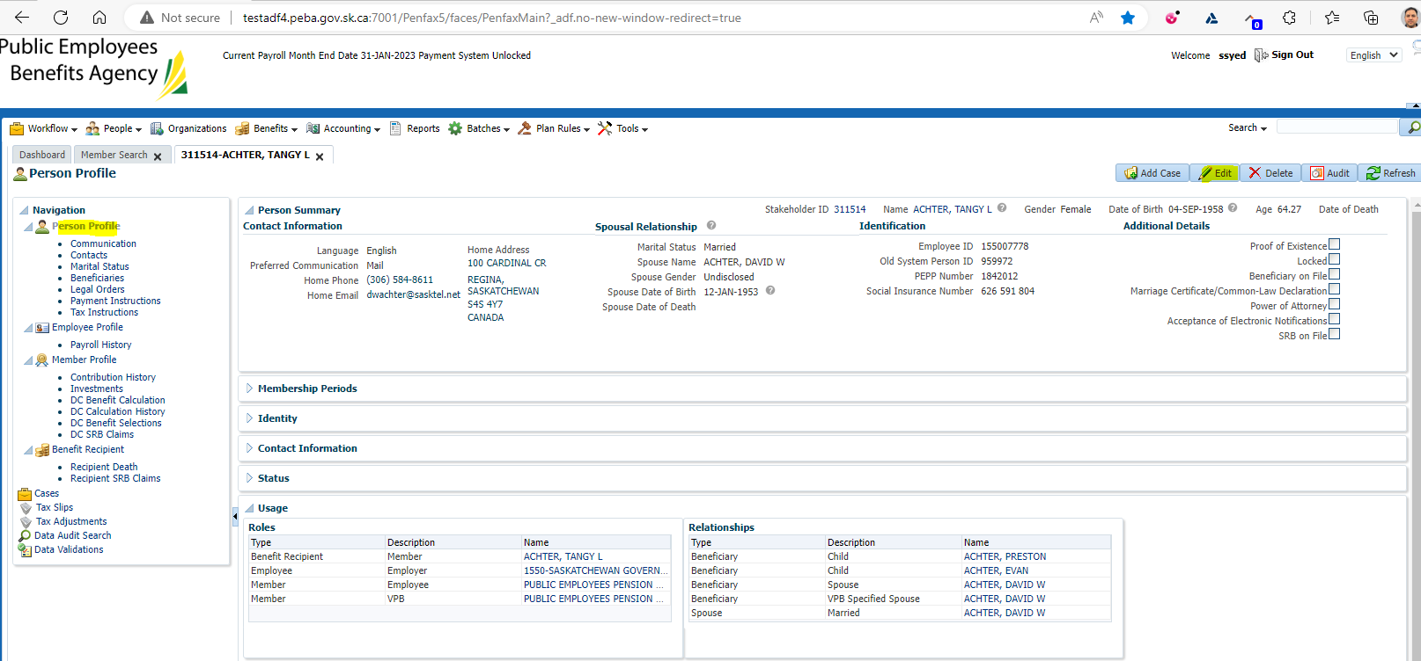

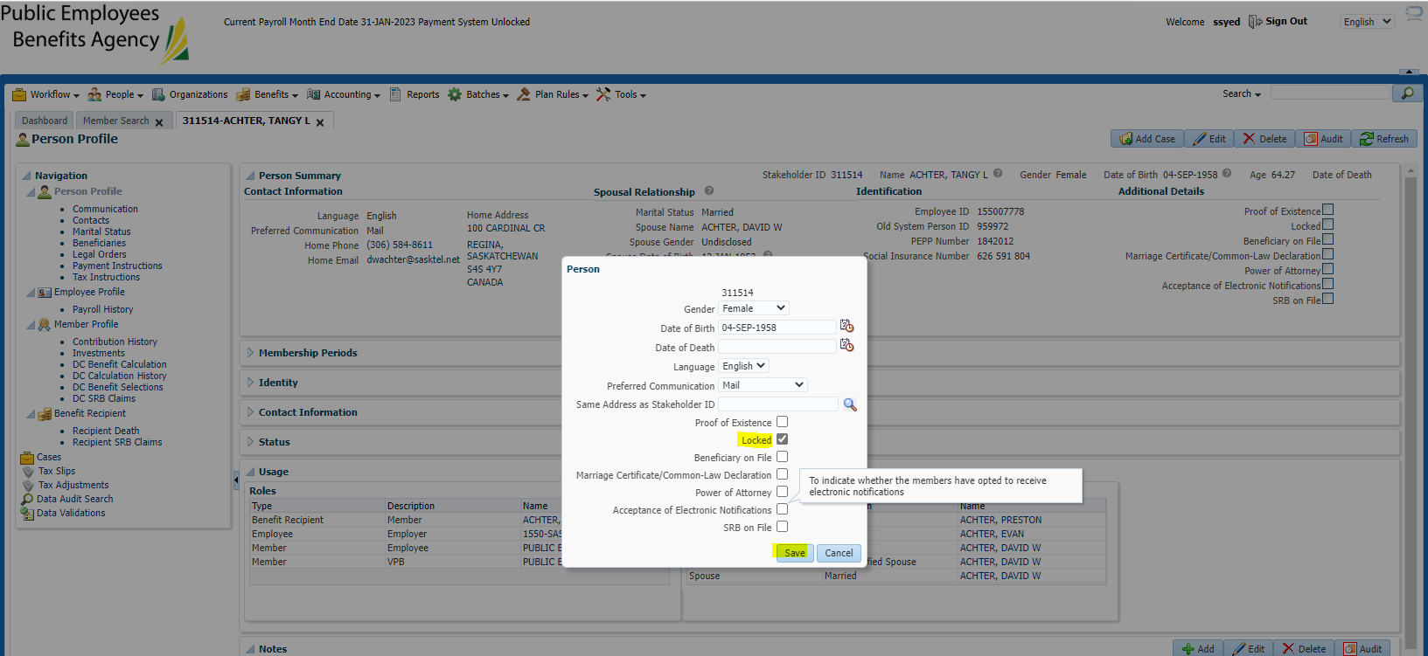

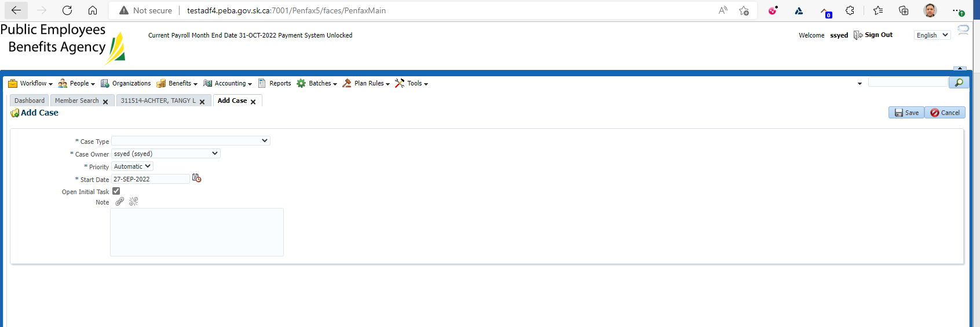

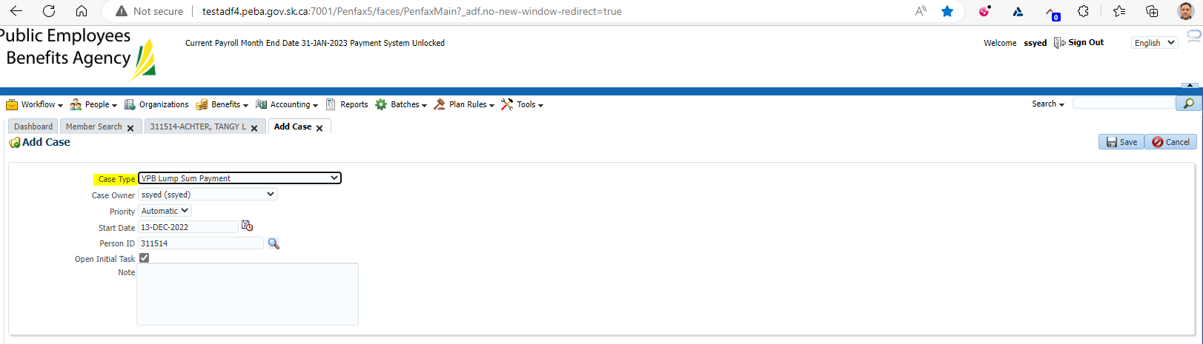

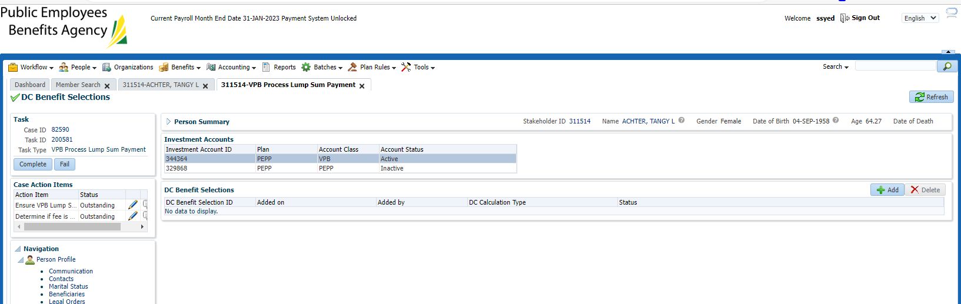

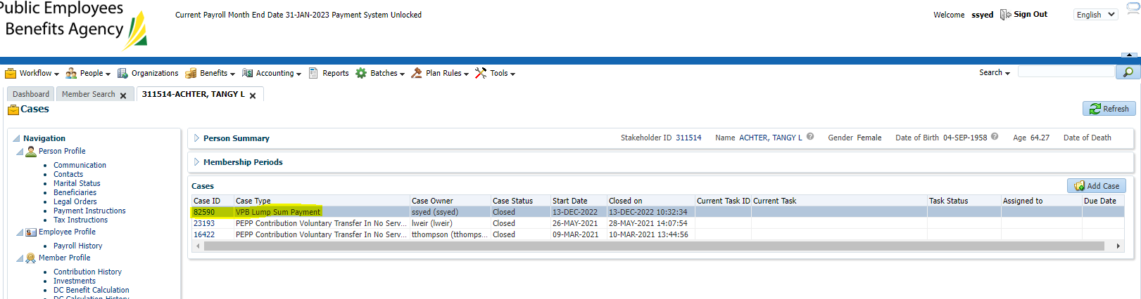

Penweb

